How to Apply:

- Login to the SAGE as an authorized official or agency administrator role:
https://njsage.intelligrants.com/Login.aspx?APPTHEME=NJSAGE

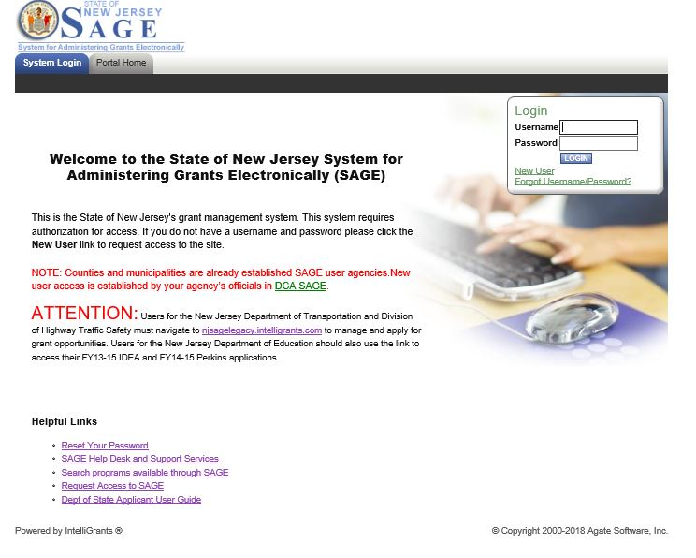

Once logged in, please look for View Available Opportunity section. Click on View Opportunities button to see which programs are open.

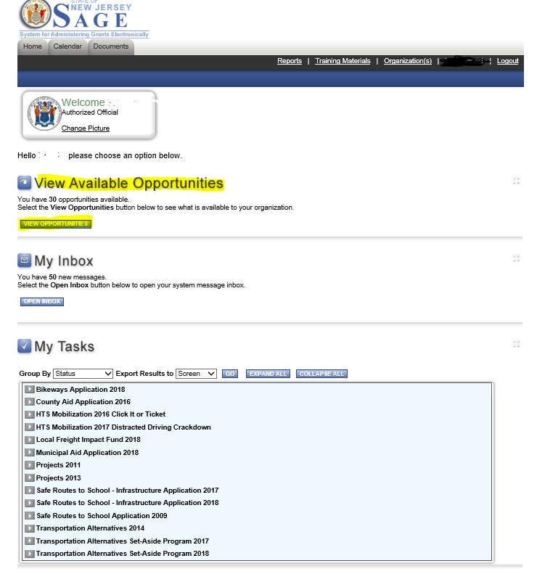

The Opportunities are listed in alphabetical order and includes all the agencies you are part of. Please scroll down to appropriate grant.

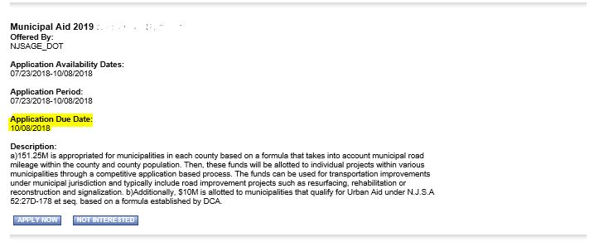

You can also search for the grant program you are looking for by using the search functionality.

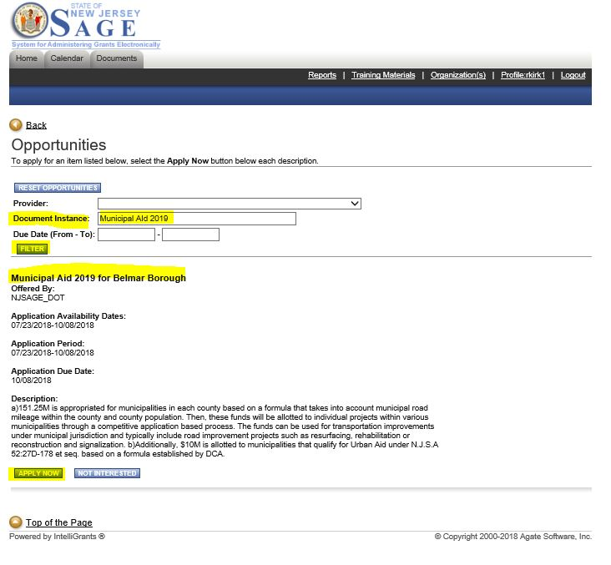

Once you find the program you are looking for, click on Apply Now button. This should start your applications.

Also, Training videos are available for guidance under “Training Materials”. Please look under “videos” Section and click on “NJDOT Application Submission” link. If you are not familiar with this version of SAGE, please look at “NJDOT IG16 Webinar” videos and the videos will walk you through the features and how to navigate in new SAGE.

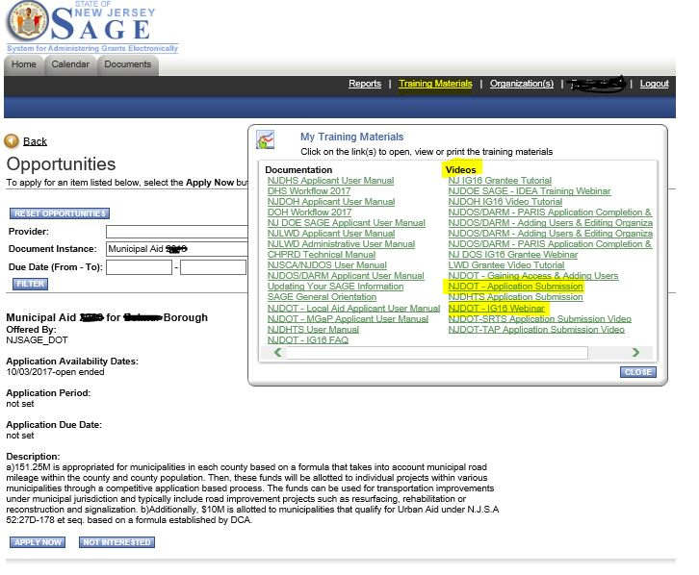

If you have any questions, please contact Local Aid Technology Solutions Group at DOT-LocalAid.TechSolutions@dot.nj.gov

