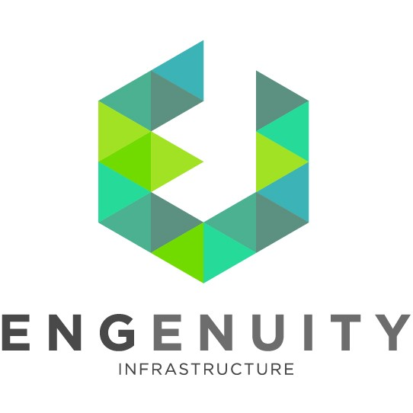

Civil Designer/ Engineer- Hydrology

Founded in 2016, ENGenuity Infrastructure is a rapidly growing, full-service planning and engineering firm focused on building resilient communities. ENGenuity balances planning principles with technical engineering expertise to achieve the goals of our clients. We are WBE, SBE, and DBE certified.

We are currently seeking a Part Time or Full Time Civil Designer or Engineer with expertise in Hydrology. The ideal candidate should be able to demonstrate skills necessary to produce drainage reports, perform hydraulic calculations, and design grading plans, utility plans and profiles, pipe profiles, earthwork analysis, stormwater management basins including retention and detention systems, and be proficient in NJ stormwater management regulations and flood hazard area control act rules. The Candidate should be familiar with the Land Development process for obtaining plan approvals, and also have experience on public projects. The Candidate should have a minimum of 5 years of experience preparing civil construction documents. Knowledge of hydrology and detention analysis and proficiency in AutoCAD Civil 3D is required.

Qualifications
- Bachelor of Science degree in Engineering
- 5+ years of experience
- Knowledge of local city, county and state land use processes and regulations (NJ)
- Fundamentals of Engineering (FE/EIT) or Professional Engineer (PE) Certification preferred
- Demonstrated Civil 3D skills with the ability to design site layouts concept through completion.
- Proficiency in technical skills in stormwater management, hydraulics, hydrological analysis, earthwork analysis, grading and other related designs. Experience using HydroCAD, PondPack, StormCAD, ArcGIS, AutoCAD Civil 3D, and the Microsoft Office Suite.
- Thorough understanding and knowledge of building codes, zoning codes and approval process as it relates to Civil Engineering.
- Excellent verbal and written communication skills. Ability to interact well with coworkers, clients, and regulatory agencies. Candidates with experience presenting projects to stakeholders and clients preferred.
- Strong attention to detail with excellent analytical and judgment capabilities. Highly organized.
- Self-starter with the ability to work independently.

Responsibilities
- Civil design including conveyance systems, drainage retention and detention systems, street analysis, planning, geometric design, conceptual layouts, grading, and hydrologic and hydraulic modeling; potable water systems, wastewater collection/conveyance systems, earthwork, and drainage systems. Coordinates, writes and/or edits specifications, drawings, reports and data sheets for projects. Develops calculations, design documents, and permit applications.
- Responsible for the technical completion of civil project services and project discipline scope elements within budget and schedule.
- Gathers information for inclusion in engineering reports, technical studies.
- Assists in the preparation of drainage construction plans and specifications for detention basins, channels and roadway projects, drainage impact studies and engineering reports.
- Perform engineering analysis associated with stormwater infrastructure improvements and evaluation of existing conditions.
- Perform quantity calculations and produce/check engineering analytical data and related information to assure the design and any technical reports are accurate.
- Completes assignments on time and on budget.

This role is based in our offices in Red Bank, NJ. Interested candidates can submit their resume and cover letter to admin@engenuitynj.com.
ENGenuity Infrastructure is an Affirmative Action and Equal Opportunity Employer, (Minority/Female/ Disabled/Veteran) participating in e-Verify.

