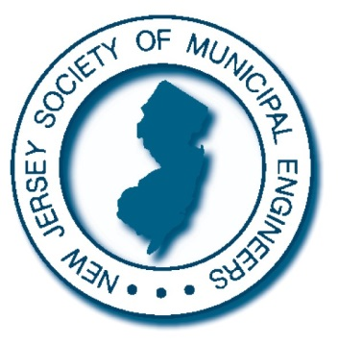

**September 14th - GENERAL MEETING**

**REGISTRATION**

(Please Register by September 12th 2016)

New Jersey Society of Municipal Engineers

414 Riverview Plaza

Trenton, NJ 08611 or Fax 609-393-9891

|  |
| --- |
| **NO PHONE RESERVATIONS WILL BE TAKEN**  **AM & Lunch – Members - $80.00 PM & Lunch - Members - $80.00**  **AM & Lunch – Non/Members - $125.00 PM & Lunch – Non/Members - $125.00**  **Full Day - Members - $120.00 Full Day – Non/Members - $175.00**  **AT THE DOOR - $15.00 extra**  Enclosed is my check or voucher in the amount of $_____ for the meeting on September 14th (Check or voucher made payable to: New Jersey Society of Municipal Engineers, Inc.)  The check or voucher is for reservations for: |
| Name |
| E-mail Address |

**\*\*\*\*Please include your address if you are not a member:\*\*\***

­­­­­­­­­­­­­­­­­­­­­­ _____________________________________________________________

**NOTE: Any voucher mailed for signature must include a**

***self–addressed stamped envelope*.**

*Secretary*

TIM STASZEWSKI, P.E.

*Vice President*

KIMBERLI CRAFT, P.E.

*President*

TODD M. HAY, P.E.

**1929 - 2016**

**NJSME.org**

**New Jersey Society of Municipal Engineers** 414 River View Plaza

Trenton, New Jersey 08611 P: (609) 393-0102

F: (609) 393-9891

E: [info@njsme.org](mailto:info@njsme.org)

NEW JERSEY SOCIETY OF MUNICIPAL ENGINEERS

IMPROVING THE QUALITY OF LIFE OF NJ COMMUNITIES THROUGH MUNICIPAL ENGINEERING

*Executive Committee*

AL YODAKIS, P.E.

JOHN P. DUPONT, P.E.

CARL E. PETERS, P.E., L.S.

RAY SAVACOOL, P.E.

ERIC BETZ, P.E.

*Treasurer*

DAN BURKE, P.E.

*Advisory Board*

THOMAS O. MINEO, P.E.

STANLEY SCHREK, P.E.

PETER C. TEN KATE, P.E.

THOMAS ZILINEK, P.E.

J. TIMOTHY KERNAN, P.E. OLGA GARCIA, P.E.

*Executive Director*

MATTHEW S. HALPIN

*Of Counsel*

GLENN C. KIENZ, ESQ.

*CME Chairman*

JOHN A. WIGGINS, P.E.