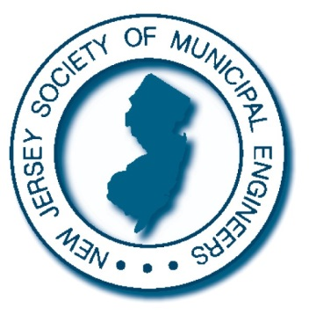

*Secretary*

TIM STASZEWSKI, P.E.

*Vice President*

KIMBERLI CRAFT, P.E.

*President*

TODD M. HAY, P.E.

**1929 - 2016**

June 15, 2016

Dear Municipal Engineer:

Yes, it’s that time of the year again! The Society is pleased to invite you to submit an entry into the 2016 Municipal Engineering Project of the Year Awards Program. By now you probably know that this program is designed to give recognition to outstanding municipal engineering projects. **This year, we have continued with an expanded program by making Engineers who are not the named Municipal Engineer also eligible to receive an award. In addition, three (3) awards will now be conferred for each of the following award categories:**

A. Municipal Construction Projects

(Full-time or Part-time Municipal Engineer)

B. Municipal Construction Projects – Populations under 20,000

(Consultant appointed as Municipal Engineer)

C. Municipal Construction Projects – Populations 20,000 and above

(Consultant appointed as Municipal Engineer)

D. Municipal Parks/Recreation Projects

(Full-time, Part-time Engineer or Consultant)

E. Municipal Management Projects

(Full-time, Part-time Engineer or Consultant)

F**.** Municipal Construction Management Projects

(Full-time, Part-time Engineer or Consultant)

G. Municipal Projects Involving Intergovernmental Cooperation

(Full-time, Part-time Engineer or Consultant)

On behalf of the Society, we encourage you to prepare an entry for this, our 39th annual awards program. Application Instructions and Guidelines are enclosed and entries are due to be completed no later than Friday, September 9th.

A panel of judges will be selected to review the entries and recommend awards. An awards presentation ceremony will be held on November 16th, 2016, at the Society’s Annual Meeting Luncheon which is held in conjunction with the 101st. Annual League of Municipalities Conference in Atlantic City.

If you have any questions please contact Lori Lee at NJSME Headquarters.

As always we remind you that participation is not only of value to you and your municipality through favorable publicity, but to the Municipal Engineering profession as a whole—please participate!

Sincerely,

Todd Hay

Todd Hay PE,

President

**NJSME.org**

**New Jersey Society of Municipal Engineers** 414 River View Plaza

Trenton, New Jersey 08611 P: (609) 393-0102

F: (609) 393-9891

E: [info@njsme.org](mailto:info@njsme.org)

NEW JERSEY SOCIETY OF MUNICIPAL ENGINEERS

IMPROVING THE QUALITY OF LIFE OF NJ COMMUNITIES THROUGH MUNICIPAL ENGINEERING

*Executive Committee*

AL YODAKIS, P.E.

JOHN P. DUPONT, P.E.

CARL E. PETERS, P.E., L.S.

RAY SAVACOOL, P.E.

ERIC BETZ, P.E.

*Treasurer*

DAN BURKE, P.E.

*Advisory Board*

THOMAS O. MINEO, P.E.

STANLEY SCHREK, P.E.

PETER C. TEN KATE, P.E.

THOMAS ZILINEK, P.E.

J. TIMOTHY KERNAN, P.E. OLGA GARCIA, P.E.

*Executive Director*

MATTHEW S. HALPIN

*Of Counsel*

GLENN C. KIENZ, ESQ.

*CME Chairman*

JOHN A. WIGGINS, P.E.